TASK 1:
// TASK 1 - 22k-4080
#include <iostream>
using namespace std;

class node{
public:
int data,key;
node* next;

node(){
key=0;
data=0;
next=NULL;
}

node(int k, int val){
key=k;
data=val;
next=nullptr;
}
};

class SinglyLinkedList
{
public:
node* head;

SinglyLinkedList(){
head = NULL;
}

SinglyLinkedList(node* n){
head = n;
}

};

int main(){
node* node1 = new node(1, 42);
node* node2 = new node(2, 53);
SinglyLinkedList list(node1);

node1->next = node2;

cout << "Node 1: Key=" << list.head->key << ", Data=" << list.head->data;
cout << endl;
cout << "Node 2: Key=" << list.head->next->key << ", Data=" << list.head->next->data;
cout << endl;

delete node1;
delete node2;

return 0;
}
OUTPUT:
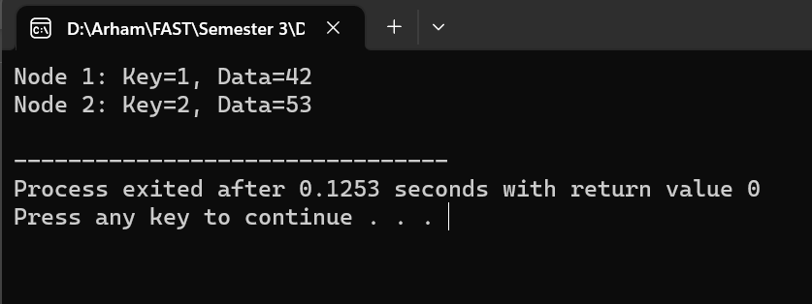
TASK 2:
// TASK 2 - 22k-4080
#include <iostream>
using namespace std;

class node{
public:
int data;
node* next;

node(int val){
data=val;
next=NULL;
}
};

void insertAtTail(node* &head, int val){
node* n = new node(val);

if(head==NULL){
head=n;
return;
}

node* temp=head;
while(temp->next != NULL){
temp=temp->next;
}
temp->next=n;
}

void display(node* head){
node* temp=head;

while(temp!=NULL){
cout<<temp->data<<"->";
temp=temp->next;
}
cout<<"NULL"<<endl;
}

int main(){

node* head = NULL;
insertAtTail(head,1);
insertAtTail(head,2);
display(head);
cout<< "After Adding 2 more Nodes:"<<endl;
insertAtTail(head,3);
insertAtTail(head,4);
display(head);

return 0;

}
OUTPUT:
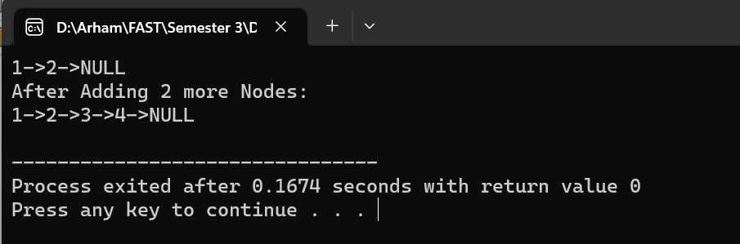
TASK 3:
// TASK 3 22k-4080

#include <iostream>
using namespace std;

class node{
public:
int data;
node* next;

node(int val){
data=val;
next=NULL;
}
};

void insertAtHead(node* &head, int val){
node* n = new node(val);
n->next=head;
head=n;
}

void display(node* head){
node* temp=head;

while(temp!=NULL){
cout<<temp->data<<"->";
temp=temp->next;
}
cout<<"NULL"<<endl;
}

int main(){

node* head = NULL;
insertAtHead(head,4);
insertAtHead(head,6);
display(head);
insertAtHead(head,5);
display(head);

return 0;
}
OUTPUT:
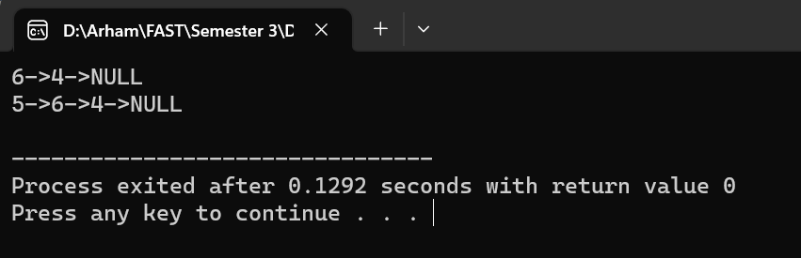

TASK 4:
// TASK 4 22K-4080
#include <iostream>
using namespace std;

class node{
public:
int data;
node* next;

node(int val){
data=val;
next=NULL;
}
};

class LinkedList {
public:
node* head;

LinkedList() {
head = nullptr;
}

void insertNodeAfter(int key, int newValue) {
node* newNode = new node(newValue);
node* current = head;

int keyAppears = 0;
while (current != nullptr) {
if (current->data == key) {
newNode->next = current->next;
current->next = newNode;
return;
}
current = current->next;
}

cout << "Key not found in the list!!" << endl;
}

void displayList() {
node* current = head;
while (current != nullptr) {
cout << current->data << " -> ";
current = current->next;
}
cout << "NULL" << endl;
}
};

int main() {
LinkedList myList;

int values[] = {4, 1, 6, 7, 2, 10};
int n = sizeof(values) / sizeof(values[0]);
node* currentNode = nullptr;

for (int i = 0; i < n; i++) {
node* newNode = new node(values[i]);
if (currentNode == nullptr) {
myList.head = newNode;
currentNode = newNode;
} else {
currentNode->next = newNode;
currentNode = newNode;
}
}

cout << "Original Linked List: " << endl;
myList.displayList();
cout << endl;

int presentNode, newData;
cout << "Enter the node after which you want to place the new node:" << endl;
cin >> presentNode;
cout << "Enter the data of new node:" << endl;
cin >> newData;
myList.insertNodeAfter(presentNode, newData);

cout << "Updated Linked List: "<< endl;
myList.displayList();

return 0;
}

OUTPUT:
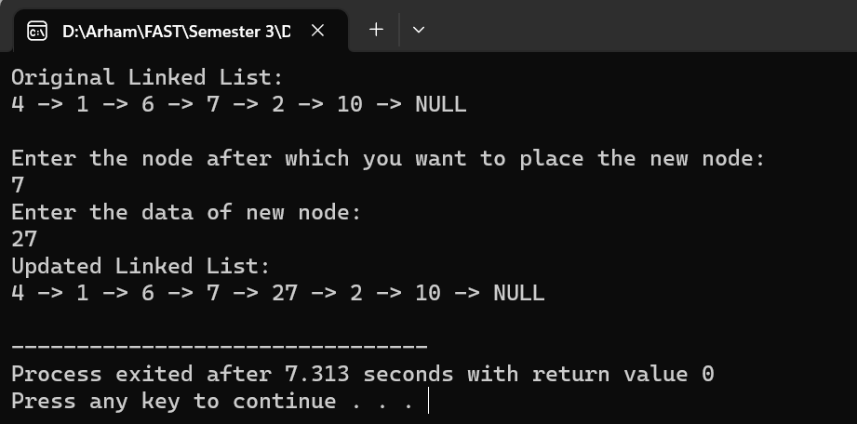
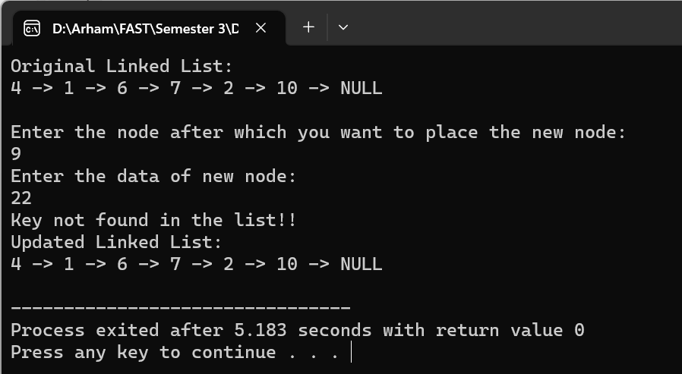

TASK 5:
// TASK 5 22K-4080
#include <iostream>
using namespace std;

class node{
public:
int data;
node* next;

node(int val){
data=val;
next=NULL;
}
};

class LinkedList {
public:
node* head;

LinkedList() {
head = nullptr;
}

node* deleteAtLast(node* head){
if (head == NULL)
return NULL;

if (head->next == NULL) {
delete head;
head= NULL;
}
node* temp = head;
node* temp2 = head;

while (temp->next != NULL){
temp2 = temp;
temp = temp->next;
}
temp2->next = NULL;
delete temp;
temp = NULL;

return head;
}

void deletion(node* &head, int val){

if(head == NULL){
return;
}

if(head->next==NULL){
node* todelete = head;
head=head->next;

delete todelete;
return;
}

node* temp = head;
while(temp->next->data != val){
temp=temp->next;
}
node* todelete=temp->next;
temp->next = temp->next->next;

delete todelete;

}

void displayList() {
node* current = head;
while (current != nullptr) {
cout << current->data << " -> ";
current = current->next;
}
cout << "NULL" << endl;
}
};

int main() {
LinkedList myList;

int values[] = {4, 1, 6, 7, 2, 10};
int n = sizeof(values) / sizeof(values[0]);
node* currentNode = nullptr;

for (int i = 0; i < n; i++) {
node* newNode = new node(values[i]);
if (currentNode == nullptr) {
myList.head = newNode;
currentNode = newNode;
} else {
currentNode->next = newNode;
currentNode = newNode;
}
}
node* head = myList.head;
cout << "Original Linked List: " << endl;
myList.displayList();
cout << endl;

int presentNode;
cout << "Enter the node to delete:" << endl;
cin >> presentNode;
cout << "Updated Linked List: " << endl;
myList.deletion(head, presentNode);
myList.displayList();

cout << "Updated Linked List(deleted at last): " << endl;
myList.deleteAtLast(head);
myList.displayList();
cout << endl;

return 0;
}
OUTPUT:
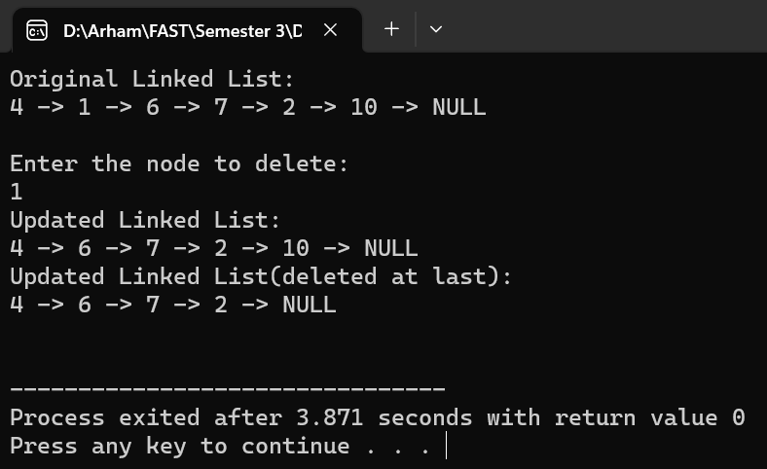
TASK 6:
// TASK 6 22k-4080
#include <iostream>
using namespace std;

class Node {
public:
int data;
Node* next;

Node(int val){
data = val;
next = NULL;
}
};

class SinglyLinkedList {
private:
Node* head;

public:
SinglyLinkedList(){
head = nullptr;
}

void addNode(int value) {
Node* newNode = new Node(value);

if (head == nullptr) {
head = newNode;
} else {
Node* current = head;
while (current->next != nullptr) {
current = current->next;
}
current->next = newNode;
}
}

bool updateNode(int position, int newValue) {
if (position < 0) {
cout << "Invalid position." << endl;
return false;
}

Node* current = head;
int currentPosition = 0;

while (current != nullptr) {
if (currentPosition == position) {
current->data = newValue;
return true;
}

current = current->next;
currentPosition++;
}

cout << "Position " << position << " is out of bounds." << endl;
return false;
}

void printList() {
Node* current = head;
while (current != nullptr) {
cout << current->data << " -> ";
current = current->next;
}
cout << "NULL" << endl;
}
};

int main() {
SinglyLinkedList myList;

myList.addNode(10);
myList.addNode(20);
myList.addNode(30);
myList.addNode(40);

cout << "Original Linked List: " << endl;
myList.printList();
cout << endl;

if (myList.updateNode(2, 35)) {
cout << "Node at position 3 updated successfully." << endl;
cout << "Updated Linked List: " << endl;
myList.printList();
} else {
cout << "Failed to update node." << endl;
}

return 0;
}

OUTPUT:
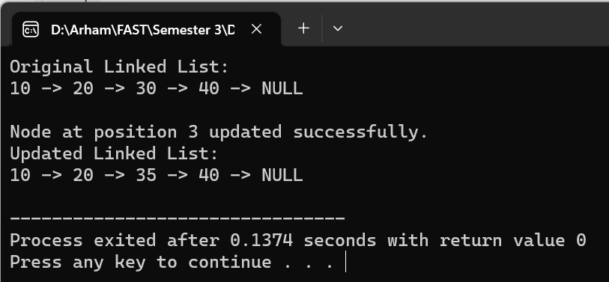
TASK 7:
// TASK 7 22k-4080
#include <iostream>

using namespace std;

struct ListNode {
int val;
ListNode* next;
ListNode(int x) : val(x), next(nullptr) {}
};

void append(ListNode*& head, ListNode*& tail, int val) {
ListNode* newNode = new ListNode(val);
if (!head) {
head = tail = newNode;
} else {
tail->next = newNode;
tail = newNode;
}
}

void printList(ListNode* head) {
ListNode* current = head;
while (current) {
cout << current->val << "->";
current = current->next;
}
cout<< "NULL" << endl;
}

ListNode* modifyLinkedList(ListNode* head) {

if (!head || !head->next) {
return head;
}

ListNode* evenHead = nullptr;
ListNode* evenTail = nullptr;
ListNode* oddHead = nullptr;
ListNode* oddTail = nullptr;

ListNode* current = head;

while (current) {
if (current->val % 2 == 0) {
append(evenHead, evenTail, current->val);
} else {
append(oddHead, oddTail, current->val);
}
current = current->next;
}

if (!evenHead) {
return head;
} else {
evenTail->next = oddHead;
return evenHead;
}
}

int main() {
ListNode* head = new ListNode(1);
int values[] = {4, 1, 6, 7, 2, 10, 8, 11, 17, 22};
int n = sizeof(values) / sizeof(values[0]);
ListNode* currentNode = nullptr;

for (int i = 0; i < n; i++) {
ListNode* newNode = new ListNode(values[i]);
if (currentNode == nullptr) {
head = newNode;
currentNode = newNode;
} else {
currentNode->next = newNode;
currentNode = newNode;
}
}

cout << "Original Linked List: " << endl;
printList(head);

ListNode* modifiedHead = modifyLinkedList(head);

cout << "Updated Linked List: " << endl;
printList(modifiedHead);

while (modifiedHead) {
ListNode* temp = modifiedHead;
modifiedHead = modifiedHead->next;
delete temp;
}

return 0;
}

OUTPUT:
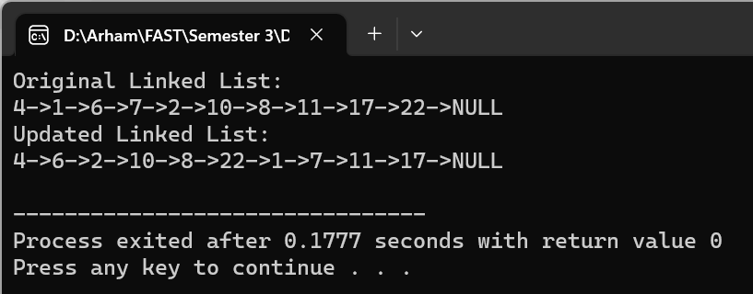

TASK 8:
//Task 8 22k-4080
#include <iostream>
#include <string>

using namespace std;

struct ListNode {
string val;
ListNode* next;
ListNode(string x) : val(x), next(nullptr) {}
};

ListNode* reverseLinkedList(ListNode* head) {
ListNode* prev = nullptr;
ListNode* current = head;
ListNode* next = nullptr;

while (current != nullptr) {
next = current->next;
current->next = prev;
prev = current;
current = next;
}

return prev;
}

bool isPalindrome(ListNode* head) {
if (head == nullptr || head->next == nullptr) {
return true;
}

int length = 0;
ListNode* current = head;
while (current != nullptr) {
length++;
current = current->next;
}

int halfLength = length / 2;
ListNode* firstHalfEnd = head;
for (int i = 0; i < halfLength - 1; i++) {
firstHalfEnd = firstHalfEnd->next;
}

ListNode* secondHalfStart = firstHalfEnd->next;
secondHalfStart = reverseLinkedList(secondHalfStart);

ListNode* p1 = head;
ListNode* p2 = secondHalfStart;
bool isPalin = true;

for (int i = 0; i < halfLength; i++) {
if (p1->val != p2->val) {
isPalin = false;
break;
}
p1 = p1->next;
p2 = p2->next;
}

secondHalfStart = reverseLinkedList(secondHalfStart);
firstHalfEnd->next = secondHalfStart;

return isPalin;
}

void printLinkedList(ListNode* head) {
ListNode* current = head;
while (current != nullptr) {
cout << current->val << " -> ";
current = current->next;
}
cout << "NULL" << endl;
}

int main() {

ListNode* head = new ListNode("c");
head->next = new ListNode("i");
head->next->next = new ListNode("v");
head->next->next->next = new ListNode("i");
head->next->next->next->next = new ListNode("c");

cout << "Original Linked List: " << endl;
printLinkedList(head);

bool isPalin = isPalindrome(head);

if (isPalin) {
cout << "The linked list is a palindrome." << endl;
} else {
cout << "The linked list is not a palindrome." << endl;
}

return 0;
}

OUTPUT:
